**Indian Institute Of Information Technology, Allahabad**

**BTech (IT) sem 4**

**SOFTWARE ENGINEERING**

SOFTWARE REQUIREMENT

SPECIFICATION DOCUMENT

**Group members:-**

CHETAN PATIDAR IIT2019193

AAMIN CHOUDHURI IIT2019206

ABHISHEK BITHU IIT2019199

DEBASISH DAS IIB2019031

-------------------------------------------------------------------------------------------------------------------------------

1. **INTRODUCTION**

It is a real-time occupancy monitoring system, which will display regular updates information about the occupancy of the buildings.The system is self paced and will not require an administrator to manage it.It will automatically not allow anybody after the building has reached its safety capacity.This system is mainly made keeping focus of auditorium buildings and will also be able to manage events.

**1.1 PURPOSE**

Occupancy monitoring will let us know the presence of people in the building in real time.

From User Point of view:-

(i) There will be no rush inside the building.

(ii) Will get notified about the vacancy of the buildings.

(iii)Will be able to manage upcoming events.

From Management point of view:-

(i) will know the check-in and check-out of each individuals

(ii) can present clear visual warnings and alerts based on the defined occupancy threshold of the building.

(iii)Will make them aware of upcoming events and will help in removing confusion between upcoming events.

**1.2 INTENDED AUDIENCE**

The intended audience mainly will be the administrator of the building.Will also include the staff and students of the IIITA institute.

**1.3 SCOPE**

**In Scope:-**

1. Building management can know when a certain someone enters the building and when they exit .
2. Knowing where people are around the building isn’t just convenient – it could be lifesaving. In an emergency like a fire, you’d know the whereabouts of anyone left in the building and be able to notify them of the emergency and their nearest exit.

**Out of Stock**

(i) the application will not be able to monitor the pattern of people assembling in some type of buildings.

ex.libraries.

**1.4 Definitions, Acronyms, and Abbreviations:**

*Acronyms and Abbreviations:*

a. ‘Project Class@’ :- App name.

b. SRS: Software Requirement Specification

*Definitions:*

a. **Project Class** :- An android application to occupancy monitoring system for IIIT Allahabad’s Students and building management for effective

administration and management of the building issues.

**1.5 REFERENCE:-**

IEEE SRS FORMAT

**1.6 Overview:**

The rest of this SRS is organized as follows: Section 2 gives an overall description of the software. It gives what level of proficiency is expected of the user, some general constraints while making the software and some assumptions and dependencies that are assumed. Section 3 gives specific requirements which the software is expected to deliver. Functional requirements are given by various use cases. Some performance requirements and design constraints are also given.

**2. Overall Description**

**2.1 Product Perspective:**

Real-time occupancy monitoring information is an important component in building energy management and security.In past, occupancy counting techniques such as laser light beam, turn-slides and infra-red sensor suﬀered from one common i.e., generally, system is accurate if one pedestrian at a time is passing the gate. Without loss of generality, aforesaid systems are inaccurate if more than one person passes the gate at one time.

So, the admin can have correct information of vacancy, occupancy of the building.

**2.2 Product Functions:**

|  |  |
| --- | --- |
| **USE CASES** | **Description Of Use Cases** |
| Login | Allow the user/admin to login |
| Sign Up | Allow the user to Sign Up |
| Choose Building | Allow the user to choose his building |
| Choose Room | Allow the user to choose his room |
| Monitor | Allow the admin to monitor the count of users |

**2.3 User Characteristics:**

a. The user/guest should be familiar with the system of entering the buildings.

**2.4 Principal Actors:**

The principal actors here are “Admin” and “User” .

**2.4 Assumptions and Dependencies:**

a. Working of this monitoring system is dependent on the availability of Internet connection.

b. Users must be active to insert all the required information while entering the building.

**2.5 USE CASE DIAGRAM :-**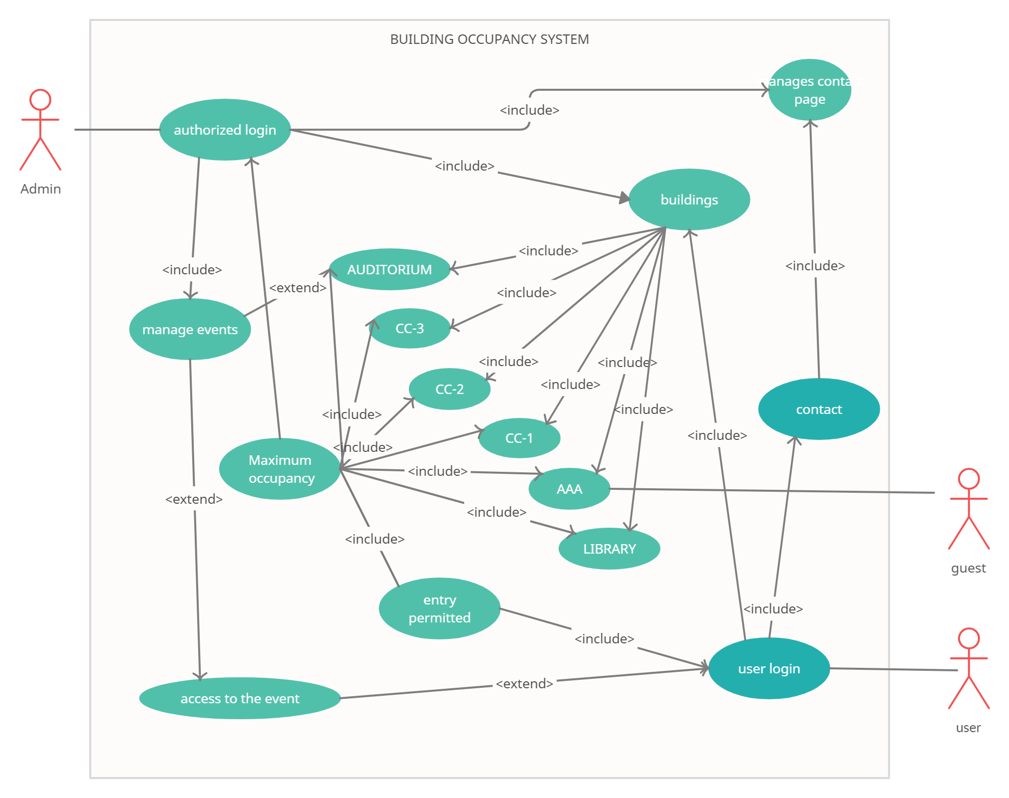

**3. System Features and Requirements**

**3.1 Functional Requirements**

We describe the functional requirements by giving various use cases.

Use Case 1:

Name: Login

Summary: Allows Admin/user to login.

Actors: User , Admin

Pre-conditions:

• Internet connectivity.

* Have all required details .

Main success scenario:

• Admin/user clicks on login button.

* Checks for the authorization of login.
* Redirected to homepage with access.

Extension:

Id or password incorrect. Shows error dialog box.

>Contact admin and provide necessary details

Use Case 2:

Name: Sign Up

Summary: Allows user to signup/registration.

Actors: User

Pre-conditions:

• Internet connectivity.

* Have all required details .

Main success scenario:

• user clicks on signup button.

* Fill all the essentials to sign up .
* Redirected to login page.

Use Case 3:

Name: Choose building

Summary: Allows users to choose building.

Actors: User

Pre-conditions:

* Internet condition
* Logged in as user

Main success scenario:

* the user will be able to choose the building he/she wanted to enter

Use Case 4:

Name: Choose room

Summary: Allows user to choose a room.

Actors: User

Pre-conditions:

* Internet condition
* Logged in as user

Main success scenario:

* the user will be able to choose the room of the building he/she wanted to enter.

Use Case 5:

Name: Monitor

Summary: Allows Admin to monitor the count of entering individuals.

Actors: Admin

Pre-conditions:

* Internet condition

Main success scenario:

* logged in with admin privileges
* grant access to view occupancy of per room.

**3.2 NON - FUNCTIONAL Requirements :-**

* The device should always be connected to the internet.
* There should be enough database space for storing the information.
* Application should be able to render it’s layout to different sizes.
* The app should be user friendly, quick in response.

**3.3 HARDWARE Requirements :-**

* It runs on Android based devices.
* Minimum 2 GB of ram is needed for smooth running of application.

**3.4 SOFTWARE Requirements :-**

* Minimum SDK version Android 4.0.3

**3.5 DESIGN CONSTRAINTS :-**

* **FAULT TOLERANCE --**

Data should not become corrupted in case of system crash or power failure.